A PROJECT REPORT
ON
“STUDENT PERFORMANCE ANALYTICS SYSTEM”
By
M. MAHESHWARI
Under the esteemed guidance of
SURISETTY CHANDINI
(Trainer)
Internship Project – “Python With AI”
EWB Edutech Private Limited
(Online Course)

Student Details:
Name - M. Maheshwari
College Name - University Post Graduate College (OU) - Siddipet
Course - MCA
Mail address - maheshwarikolpur98@gmail.com
Project Name - Student Performance Analytics System
Internship Domain - Python With AI

INDEX

SI.NO. | TITLE | PAGE NO
1 | ABSTRACT | 3
2 | OBJECTIVES | 3
3 | TECHNOLOGIES USED | 3
4 | DATASET DESCRIPTION | 4
5 | IMPLEMENTATION | 4-5
6 | KEY FEATURES | 6
7 | SYSTEM TESTING | 6-7
8 | OUTPUT/SCREENSHORTS | 7-9
9 | FINAL OUTCOME | 9
10 | CHALLENGES & LEARNING | 10
11 | GITHUB REPOSITORY | 10

1. ABSTRACT
The Student Performance Analytics System is a Python-based project that reads student data and analyzes it using NumPy and Pandas. The dataset contains student ID, name, subject marks and attendance. The system calculates total and average marks, assigns grades, and finds pass/fail students. It also shows subject-wise performance, top-performing students, and students with low attendance. The results are displayed clearly so that the performance of the whole class can be understood easily.
2. OBJECTIVES
Teachers usually keep student marks and attendance in spreadsheets and calculate totals, averages, grades and pass/fail results by hand. This is slow and easy to get wrong.
This project reads student records from a CSV file, processes them with Python, NumPy and Pandas, and produces a clear performance report: totals, averages, grades, pass/fail statistics, subject-wise analysis, top performers and low-attendance students. The same results are also shown in a web dashboard for easy viewing.

3.TECHNOLOGIES USED

Technology | Purpose
Python | Main programming language, functions and loops
NumPy | Numerical calculations (sum, mean, max, min, conditions)
Pandas | Loading the CSV, DataFrame operations, filtering, grouping, sorting
CSV file | Storing student records
HTML, CSS, JavaScript | Web dashboard (hosted on GitHub Pages)
Git and GitHub | Version control and project submission

4. DATASET DESCRIPTION
The dataset is stored in students.csv. Each row is one student.
Column | Description
id | Unique student ID (101–112)
name | Student name
Python | Marks in Python (out of 100)
HTML | Marks in HTML (out of 100)
CSS | Marks in CSS (out of 100)
JavaScript | Marks in JavaScript (out of 100)
attendance | Attendance percentage
The sample dataset has 12 student records with realistic marks and attendance values.
5. IMPLEMENTATION
Step 1 – Prepare the dataset. A CSV file was created with student ID, name, four subject marks and attendance.
Step 2 – Read the data. The CSV is loaded into a Pandas DataFrame using pd.read_csv(). The columns, number of records and basic information are displayed with head(), shape and info().
Step 3 – Process the data. Reusable functions perform the calculations:
- Total marks per student: sum of the four subject marks (NumPy sum along the row axis).
- Average marks per student: total divided by the number of subjects.
- Grade: assigned by a loop/function using the grading rule below.
- Result: Pass or Fail using the pass condition below.
Grading rule (based on average marks)
Average | Grade
90 and above | A+
80 to 89.99 | A
70 to 79.99 | B
60 to 69.99 | C
Below 60 | D
Pass condition: a student passes if they score at least 40 marks in every subject; otherwise the student fails.
Step 4 – Perform analysis. The program answers practical questions:
- Which student has the highest and lowest total?
- What is the overall class average?
- How many students passed and failed?
- Which subject has the best average?
- Who are the top 5 students?
- Which students have attendance below 80%?
Step 5 – Final output. Results are printed in a readable format in the console and are also presented in the web dashboard (class summary, subject-wise average, grade distribution, top 5 students, subject toppers and low-attendance list).
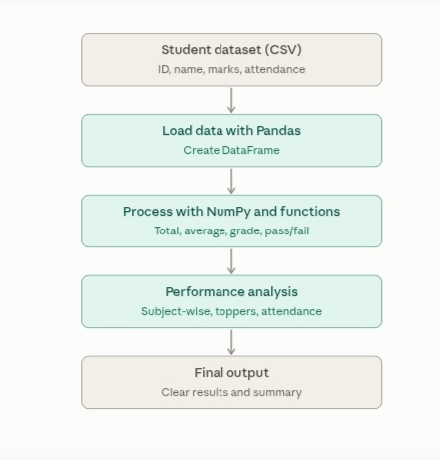

6. KEY FEATURES
- Loads student data from a CSV file into a Pandas DataFrame.
- Calculates total and average marks for each student.
- Assigns grades using a clearly defined grading rule.
- Identifies pass/fail students.
- Finds highest, lowest and average performance.
- Subject-wise average and subject-wise topper.
- Grade distribution (count of A+, A, B, C).
- Top 5 performing students.
- Low-attendance alert (below 80%).
- Search by student ID and filter by name or pass/fail in the dashboard.
CSV download, copy, upload and reset-to-sample-data options in the dashboard.

7. SYSTEM TESTING
The project was tested to make sure all calculations and outputs are correct and the program runs without errors.
No. | Test Case | Expected Result | Actual Result | Status
1 | Load the student CSV file | Data loads into a Pandas DataFrame | Data loaded successfully | Pass
2 | Check columns and number of records | All columns and records are displayed | Displayed correctly | Pass
3 | Calculate total marks | Total equals the sum of all subject marks | Matched manual calculation | Pass
4 | Calculate average marks | Average equals total divided by number of subjects | Matched manual calculation | Pass
5 | Assign grades | Grade matches the defined grading rule | Grades assigned correctly | Pass
6 | Identify pass/fail students | Students are marked based on the pass condition | Status shown correctly | Pass
7 | Subject-wise analysis | Average of each subject is calculated correctly | Results were correct | Pass
8 | Find top-performing students | Students with the highest totals are listed first | Top students identified correctly | Pass
9 | Highest, lowest and class average | Correct values are displayed | Matched manual check | Pass
10 | Run the complete program | Program runs without errors | Ran successfully | Pass
Result: All test cases passed. The system gives correct and consistent results for the given dataset.

8. OUTPUT SCREENSHORTS

- Class summary (total students, class average, highest and lowest total, pass/fail count)
- Subject-wise average and grade distribution
- Top 5 students and subject toppers
- Web dashboard screenshots

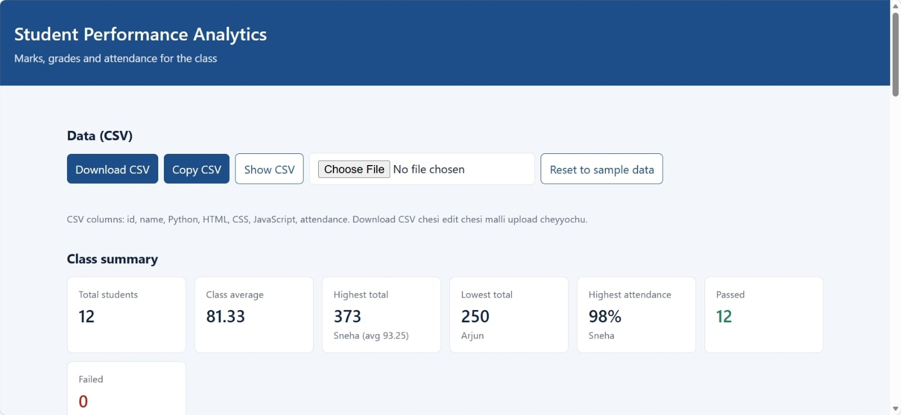
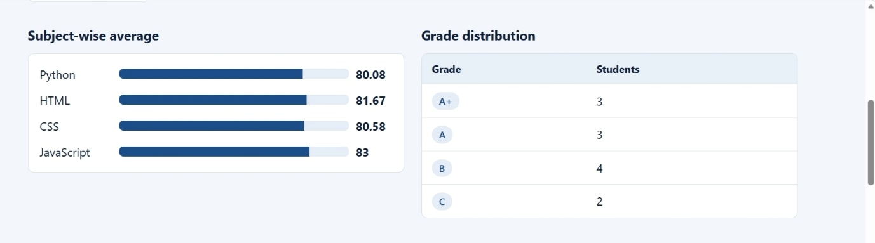

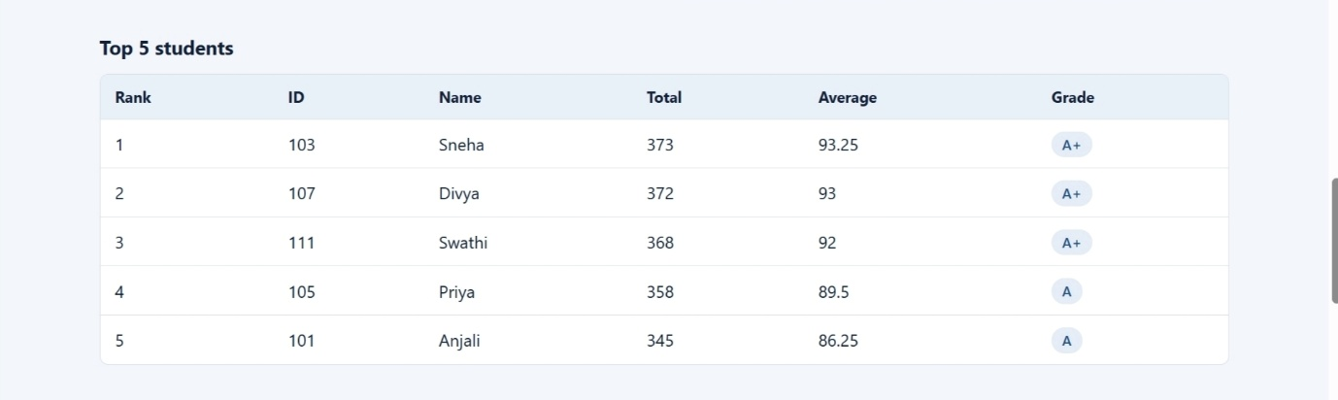

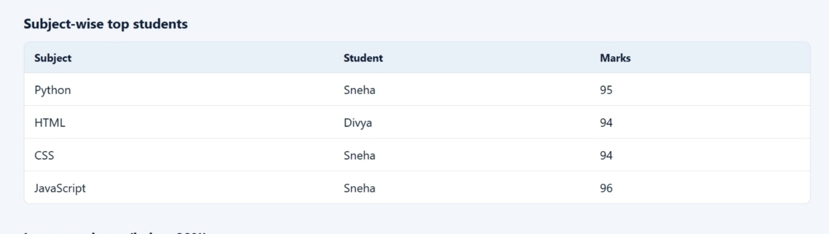

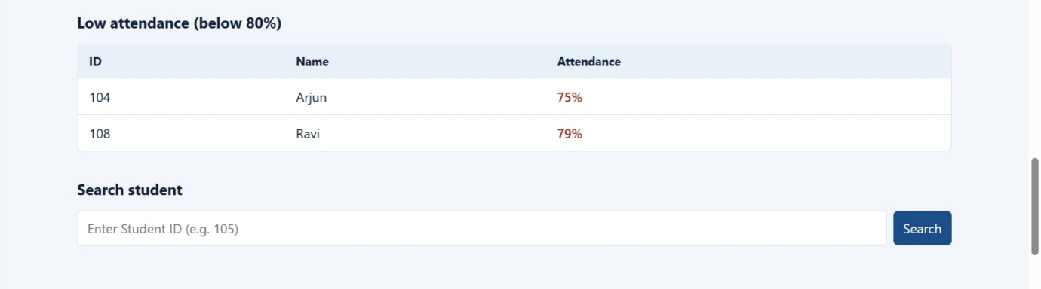
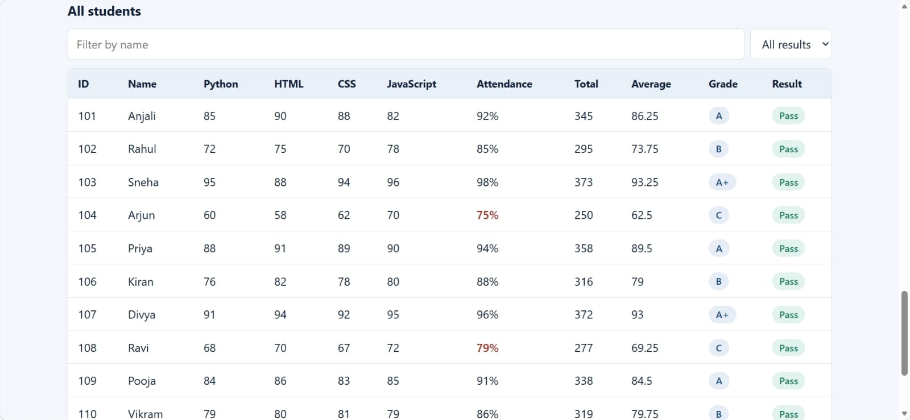

9. FINAL OUTCOME

The project successfully analyses the class data and produces these results for the sample dataset of 12 students:
- Class average: 81.33
- Highest total: 373 (Sneha, average 93.25)
- Lowest total: 250 (Arjun)
- Passed: 12, Failed: 0
- Subject-wise averages: Python 80.08, HTML 81.67, CSS 80.58, JavaScript 83 (JavaScript is the best subject)
- Grade distribution: A+ 3, A 3, B 4, C 2
- Top 5: Sneha, Divya, Swathi, Priya, Anjali
Low attendance (below 80%): Arjun (75%), Ravi (79%)

10. CHALLENGES & LEARNING
- Applying grades row by row: deciding between a loop and a Pandas apply(). Solved by writing one reusable grade function and applying it to every student.
- Pass/fail logic: a good average can hide a failed subject, so the condition checks every subject, not only the average.
- Clean output: raw DataFrames are hard to read, so results are formatted with clear headings.
- Git and GitHub: learned to create a repository, commit, push and verify files online.
What I learned: writing reusable functions, using loops and conditions, NumPy for numerical work, Pandas for data analysis, and organising a project for submission.

11. GitHub Repository

- Repository: Git
- Live dashboard: Git

